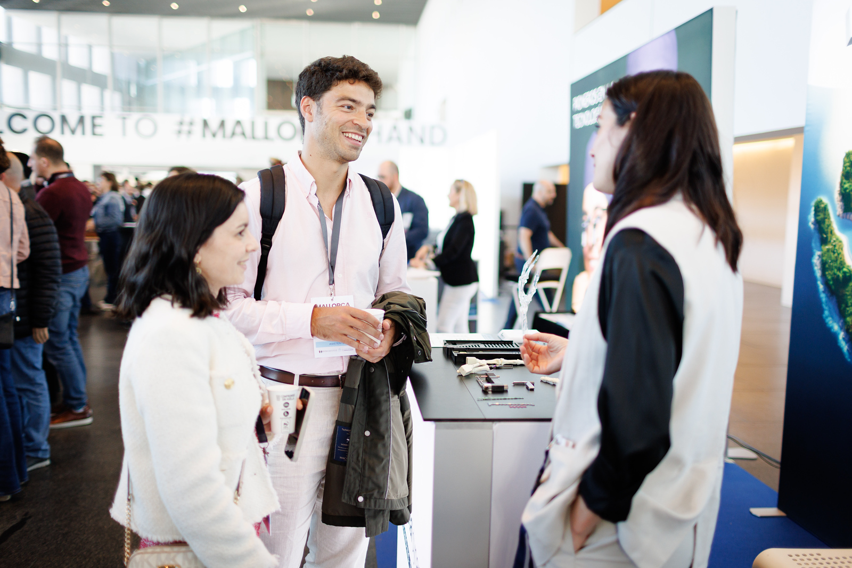

|  |
| --- |
| TRADE  OPPORTUNITIES |

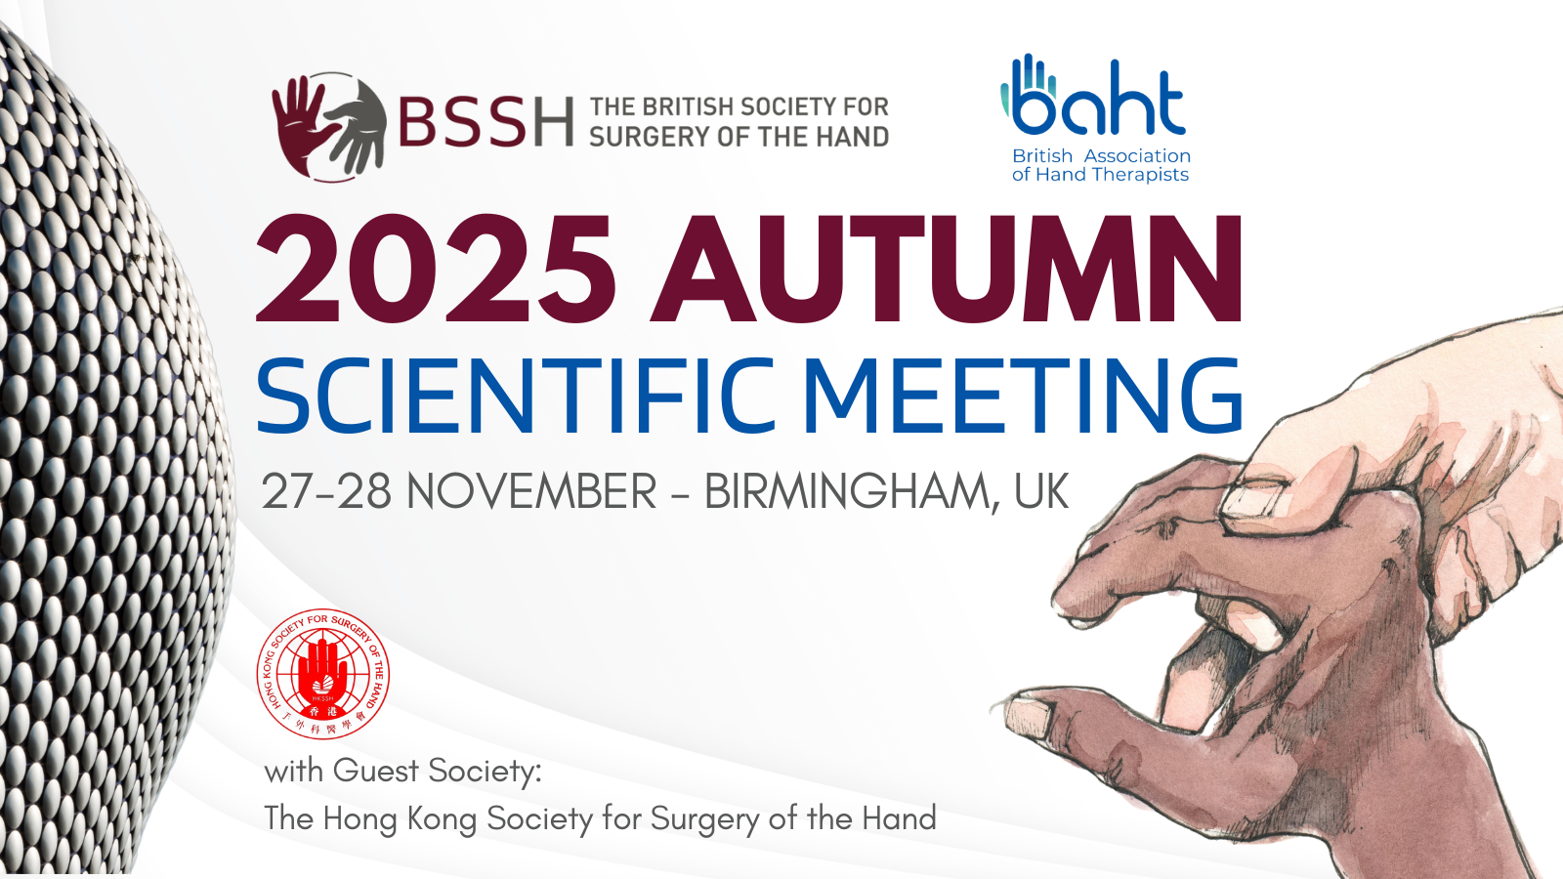

# BSSH & BAHT Combined Autumn Scientific Meeting

The British Society for Surgery of the Hand (BSSH) and The British Association of Hand Therapists (BAHT) are excited to invite you to their combined Scientific meeting in Birmingham this November with Guest Society, The Hong Kong Society for Surgery of the Hand.

Birmingham, the second largest city of the United Kingdom, lies near the geographic centre of England. Situated at the crossing points of the national railway and motorway systems, along with Birmingham International Airport on its doorstep, it is easily accessible for UK and international delegates.

## Date

Thursday 27th to Friday 28th November 2025

## Venue

Eastside Rooms  
Woodcock St  
Birmingham  
B7 4BL

# Exhibition floorplan

# Trade Opportunities

This is a two-day meeting taking place from Thursday 27th to Friday 28th November 2025, where the catering and exhibition will be located in one area. 19 stands are available which will be sold on a first come, first served basis.

We are happy to work with you to create bespoke packages to meet your individual requirements, such as:

* Educational Partnerships
* Workshops
* Sponsoring a session

Or choose from our packages and options:

|  |  |
| --- | --- |
| EXHIBITION STAND PACKAGE | £3,500 + VAT |
| * One tabletop exhibition stand * 1 Society Dinner ticket (additional available at fee) * Logo and company bio in printed programme and event app * Logo on website * Logo on holding slide * Catering for up to two representatives, including lunch and refreshments during breaks * Electrical sockets | |

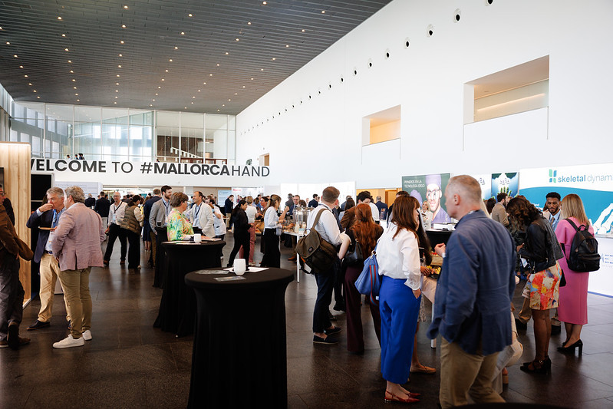

# Additional sponsorship opportunities

|  |  |
| --- | --- |
| OPTION 1 - Drinks reception sponsorship | £3,500 + VAT |
| BSSH & BAHT Drinks Reception Sponsorship, including:   * Advertising of drinks reception on event app, printed programme and website * Sponsored drinks reception advertised via email to delegates and BSSH Members | |

|  |  |
| --- | --- |
| OPTION 2 – Meeting WI-FI | £3,500 + VAT |
| * The company will be able to choose the username and password for the meeting | |

|  |  |
| --- | --- |
| OPTION 3 – Refreshments sponsorship | £3,000 + VAT |
| * The logo of the sponsorship company will be displayed during the coffee/tea breaks in the service selected by the company. | |

|  |  |
| --- | --- |
| OPTION 4 – Poster area sponsorship | £2,500 + VAT |
| * The logo of the sponsorship company will be shown on the interactive e-poster screens | |

|  |  |
| --- | --- |
| OPTION 5 – Poster Prize sponsorship | £250 + VAT |
| * Prize to be named after sponsor * Advertising of poster prize sponsorship in programme and event app | |

|  |  |
| --- | --- |
| OPTION 6 – Lunchtime symposium | £1,000 + VAT |
| * Symposium added to the printed programme, event app and website * Industrial symposium during lunch break | |

|  |  |
| --- | --- |
| OPTION 7 – Lanyards | £1,000 + VAT |
| * Lanyards will be provided by the sponsorship company with the corporate logo | |

|  |  |
| --- | --- |
| OPTION 8 – Push notification in app | £500 + VAT |
| * Event app push notification sent to all delegates | |

|  |  |
| --- | --- |
| OPTION 9 - Advert | £1,500 + VAT |
| * Full-page, full colour advert in A5 printed programme * Advert in meeting app | |

# TRADE Booking form

BSSH BAHT Combined Autumn Scientific Meeting 2025 - 27-28 November 2025, Birmingham

|  |  |
| --- | --- |
| ****COMPANY DETAILS**** | |
| Company name | Click or tap here to enter text. |
| Contact name All conference information will be sent to the named contact | Click or tap here to enter text. |
| Finance department contact  (for invoicing queries) | Click or tap here to enter text. |
| Company Address (for invoicing) | Click or tap here to enter text. |
| VAT Registration Number | Click or tap here to enter text. |
| Email address | Click or tap here to enter text. |
| Telephone number | Click or tap here to enter text. |
| PO number for invoice | Click or tap here to enter text. |

|  |  |  |
| --- | --- | --- |
| **TRADE SPONSORSHIP** | **COST (excl.VAT)** | **SELECT** |
| Exhibition stand Package  *Please state requested stand number:* | £3,500 | Click or tap here to enter text. |
| Option 1 – Drinks reception sponsorship | £3,500 |  |
| Option 2 – Meeting WIFI | £3,500 |  |
| Option 3 – Refreshments sponsorship | £3,000 |  |
| Option 4 – Poster area sponsorship | £2,500 |  |
| Option 5 – Poster prize sponsorship | £250 |  |
| Option 6 – Lunchtime symposium | £1,000 |  |
| Option 7 – Lanyards | £1,000 |  |
| Option 8 – Push notification in app | £500 |  |
| Option 9 – Advert | £1,500 |  |
| Additional dinner tickets (one included in exhibition stand package - state additional quantity required) | £75/each | Click or tap here to enter text. |
| **TOTAL SPONSORSHIP TO INVOICE** | Click or tap here to enter text. | |

|  |  |
| --- | --- |
| DETAILS FOR WEBSITE AND PRINTED PROGRAMME | |
| Company name | Click or tap here to enter text. |
| Contact description  (100 words max) | Click or tap here to enter text. |
| Company address | Click or tap here to enter text. |
| Email address | Click or tap here to enter text. |
| Telephone number | Click or tap here to enter text. |
| Website | Click or tap here to enter text. |
| Have you attached/emailed company logo? (yes/no) | Click or tap here to enter text. |

Sponsorship and Exhibition Agreement - Terms and Conditions

**Payment Terms:** 30 days from date of invoice. Please note we cannot confirm stand space until full payment of our invoice has been received.

**Cancellation Policy:** A refund will be applied if the event is postponed or cancelled. A refund will not be given if the client cancels within 30 days of the event.

**Delegate List:** Due to GDPR legislation, we no longer provide a printed delegate list. However, you can access this information within the event app.

**Please return completed form to** [**secretariat@bssh.ac.uk**](mailto:secretariat@bssh.ac.uk)